Government Expenditure & Projects Efficiency Authority (EXPRO)

PDCA (Plan-Do-Check-Act) Template

Document No. EPM-EQ0-TP-000003 Rev 001

Document Submittal History:
Rev.: | Rev Status | Date: | Entity | Prepared by: | Checked by: | Reviewed by: | Approved by: | Authorization:
XXX | For XXX | 06/07/2021 | EXPRO | M. Almarshed | R. Alsalooly | H. Alghofaily | Name | A AlAujan

THIS NOTICE MUST ACCOMPANY EVERY COPY OF THIS DOCUMENT
IMPORTANT NOTICE

This document, (“Document”) is the exclusive property of Government Expenditure & Projects Efficiency Authority.
This Document should be read in its entirety including the terms of this Important Notice. The government entities may disclose this Document or extracts of this Document to their respective consultants and/or contractors, provided that such disclosure includes this Important Notice.
Any use or reliance on this Document, or extracts thereof, by any party, including government entities and their respective consultants and/or contractors, is at that third party’s sole risk and responsibility. Government Expenditure and Projects Efficiency Authority, to the maximum extent permitted by law, disclaim all liability (including for losses or damages of whatsoever nature claimed on whatsoever basis including negligence or otherwise) to any third party howsoever arising with respect to or in connection with the use of this Document including any liability caused by negligent acts or omissions.
This Document and its contents are valid only for the conditions reported in it and as of the date of this Document.

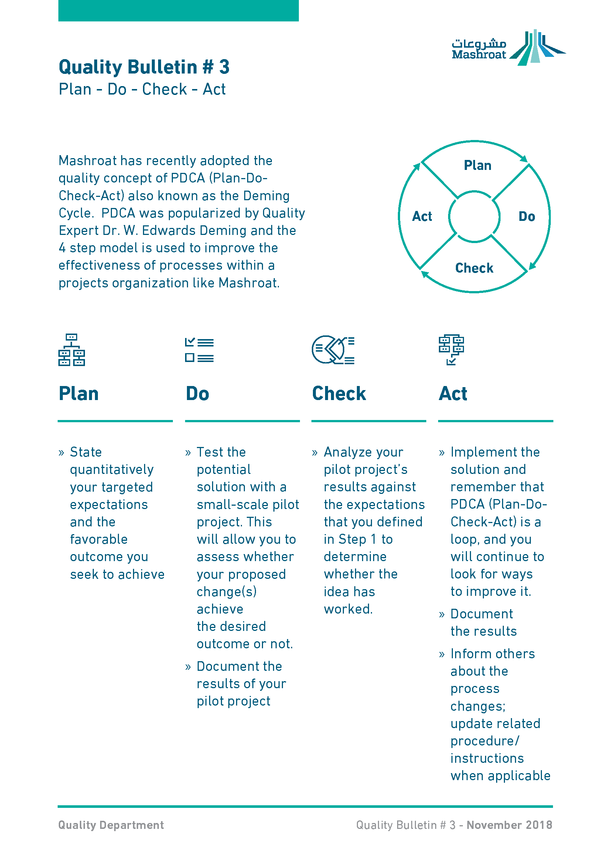
XXXXXXXX has recently adopted the quality concept of PDCA (Plan-Do-Check-Act) also known as the Deming Cycle. PDCA was popularized by Quality Expert Dr. W. Edwards Deming and the 4 step model is used to improve the effectiveness of processes within a projects organization like XXXXXXXX.

Plan | Do | Check | Act
- State quantitatively your targeted expectations and the favorable outcome you seek to achieve | - Test the potential solution with a small-scale pilot project. This will allow you to assess whether your proposed change(s) achieve the desired outcome or not.  - Document the results of your pilot project | - Analyze your pilot project’s results against the expectations that you defined in Step 1 to determine whether the idea has worked | - Implement the solution and remember that PDCA (Plan-Do-Check-Act) is a loop, and you will continue to look for ways to improve it.  - Document the results  - Inform others about the process changes; update related procedure/instructions when applicable

